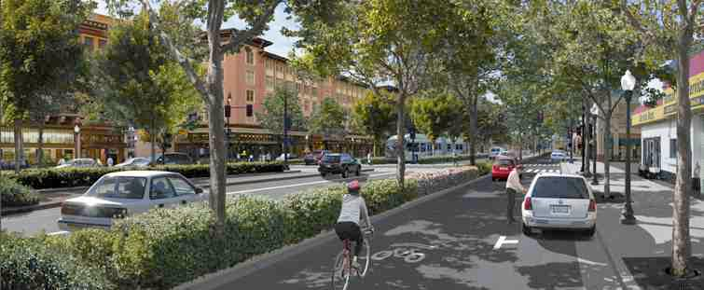

Growing Portland: Not Whether but How
A Collaboration among Creative Portland, Muskie School of Public Service, Portland Regional Chamber, and Portland Society for Architecture

The following individuals participated in the collaboration, its conception and development, three urban design charrettes, and an open critique session: Principals: Richard Barringer, Muskie School of Public Service; Sondra Bogdonoff, Creative Portland; Patrick Costin, Portland Society for Architecture; Chris Hall, Portland Regional Chamber of Commerce; Joseph McDonnell, Muskie School of Public Service; Carole Merrill, Portland Society for Architecture; Paul Stevens, Portland Society for Architecture. Charrette Participants: Jesse Thompson (Facilitator), Richard Barringer, Peter Bass, Paul Becker, Michael Belleau, Sondra Bogdonoff, Michael Bourque, James Brady, Chris Cantwell, Evan Carroll, Phil Chaney, Jennifer Claster, Patrick Costin, John Gallagher, Mark Googins, Joseph Gray, Chris Hall, Quincy Hentzel, Tim Honey, Ian Jacob, Alex Jaegerman, Mark Johnson, Jack Kartez, Alyssa Keating, Paul Lewandowski, Jack Lufkin, Joseph McDonnell, Edward McGarrity, Gerry Mylroie, Firooza Pavri, Alyssa Phanitdasack, Casey Prentice, Lynn Shaffer, Joanna Shaw, Julia Tate, Barry Sheff, Addy Smith-Reiman Paul Stevens, Russ Tyson, Ryan Wallace, Lisa Whited. Critique Jurors: Alex Landry, Christian Milneil, Carol Morris, Jaime Parker, Cap Prasch, Amy Segal, Sally Struever. All are especially grateful to Carole Merrill, Executive Director of the Portland Society for Architecture, and to Sondra Bogdonoff, Acting Executive Director of Creative Portland, for their organizational skills and support that made this collaboration possible.
Contents: I. Not Whether but How: Making the Case, p. 1
II. Some Illustrations of the Concept and Vision, p. 14
III. Portland’s Workforce Dynamics, 2004-2014, p.15
IV. “The New Allure of the City” (a summary) p. 23

I. Not Whether but How: Making the Case
by Richard Barringer and Joseph McDonnell, with John Dorrer and Ryan Wallace

Introduction. This is a singular moment in the long and fabled history of Portland, Maine. It today possesses all the ingredients for a successful and sustainable city, save its compelling needs for more housing, more workforce, and more public capital investment.
In the 400 years since European settlement, Portland has survived the repeated ravages of war, invasion, pestilence, conflagration, and economic depression and recession. Once a renowned manufacturing, trade, and shipping center, it now enjoys what might be called a post-industrial renaissance as a vibrant center for the arts, education, entertainment, and banking, legal, and medical services; and is frequently cited as one of America’s best small cities in which to live, work, play, and visit.
As a result, Portland is growing today and is positioned for more growth, most likely much more. Since 2014 it has approved more than 1600 new housing units, of which almost half are in construction or complete; and if the market continues its present course, the city could soon realize a total of 2700, an 8 percent increase in its total number of housing units. Meanwhile, forces loose in the world position Portland for even greater growth. These include the job-creating spread effects of a resurgent Boston, the workforce demands of a post-industrial economy, the new attractiveness of cities to the young and old alike, the global migration of displaced peoples, and even the warming effects of climate change.
The question, then, is not whether Portland will grow, but how well it will grow; or, how best to manage the growth that is now certain to come. Will this growth be reactive, driven solely by market forces and the drive for profit? Or will it, as well, be intentional, responsive to longstanding traditions and public values, and lead to an ever-more attractive place in which to live, work, and play? Will it be a city designed especially to accommodate cars, or will it return to a more livable place of connected neighborhoods, each with its own distinctive character?
History is trending in Portland’s favor today; and if we make the right choices, we may be in for a long run as a successful city. Over the past six months Creative Portland, the Muskie School, the Portland Regional Chamber, and the Portland Society for Architecture have collaborated to explore these questions. We conclude that:
- First, Portland today faces not one but three great challenges, workforce development and housing, two sides of the same coin, and the need for greater investment in its publicly-owned capital assets;
- Second, if Portland is to sustain its current prosperity and fulfill its vital economic role for all Maine, it must grow its workforce, broaden its property tax base, strengthen its schooling, expand its public transit, and – most importantly – create more housing and commerce along major thoroughfares and in select neighborhood centers on and off the peninsula; and
- Third, if Portland is to retain and expand its attractiveness as a city, it must pay careful attention throughout to matters of good urban planning, design, and investment, learning from other successful cities.

Here, in simplest terms, is how this approach to Growing Portland works: residential and commercial growth, properly planned and sited, will increase net revenues coming into city coffers. With an effective plan to address its long-term capital needs, the city now has increased resources to invest in its quality of life assets, which attract more people and businesses.
This is the generative or “virtuous” cycle of growth, promoting sustainable development; but it is a cycle that may become degenerative or “vicious,” leading to a downward spiral, if the net revenues of growth are not captured and carefully reinvested in the city’s public assets and quality of life.

The Renaissance of the Cities. The Bangor Daily News editorial board recently declared, “Cities are the way of Maine’s future. Maine must embrace that reality.” It argues that even in a rural state like Maine, cities are the engines of innovation that now drive the state’s economy. “Maine’s rural character might distinguish us from other states,” it concludes, “but its urban areas will more likely than not drive its growth. These urban areas need strong advocates who can make the case for policies that help it along.”
Portland and its surrounding region are more important than ever to Maine’s overall economic prosperity. Recent analysis for the U.S. Conference of Mayors reveals that the Portland-South Portland-Biddeford region now accounts for more than one-half of the state’s entire economy. When combined with Bangor and Lewiston-Auburn, this increases to fully two-thirds of the state’s economy. See Portland Press Herald, June 24, 2016.
Cities across the country and the world originally thrived because of their proximity first to water and then to rail lines. This is true of Portland as well as all the great cities along both coasts, the Gulf, and the Great Lakes. As automobiles, trucks, and airplanes replaced water and rail, manufacturers moved to the suburbs or failed to compete with southern U.S. and, later, offshore manufacturers, leaving many post-World War II cities like Portland as hollowing shells without enough business to drive their regional economies.
The rise of the suburbs after the war offered young families an escape from the noise, pollution, poverty, and crime of declining cities. The suburbs seemed ideal places to raise children with their good schools, safe neighborhoods, and single family homes with a garage for the car and a yard for the children. These attributes outweighed the suburb’s disadvantages of racial homogeneity, limited cultural stimulation, overdependence on the automobile, and the loss of farmland and its environmental amenities.
As Harvard design professor Alex Krieger points out, suburbs were particularly attractive when well more than half the households in the country had children of school age; but today that number has dwindled to just over 20 percent. As older people live longer and younger people take more time to secure an education and start a career, cities have become more attractive for many single adults, empty-nesters, professionals, and millennials.
Kennedy School economist Edward Glaeser notes that successful cities around the world today are powerful magnets for people, facilitating interaction among them and competition among firms in emerging and growing industries. They offer vast opportunity for employment and upward mobility, accommodate diverse peoples of all incomes and social classes, and ensure the availability of shelter, affordable to all.
Cities like New York, Boston, Minneapolis, and San Francisco have been reinvented by entrepreneurial innovators – in financial services in New York, in technology and bio-sciences in Boston, in medical devices and retail in Minneapolis, and in information technology in San Francisco and the Silicon Valley. Tourism, the arts, and educational institutions have played major roles in the revitalization of each of these cities.
Urbanist Jane Jacobs urges cities to create dense, mixed-use neighborhoods that bring together housing, businesses, shops, cultural venues, green space and pocket parks to create lively neighborhoods where residents may walk to shop, work, play, rest, engage, and visit places of interest. This increased density creates more households and commercial businesses on a relatively small footprint, with the added benefit of more people to support the city’s tax base, curbing anticipated tax increases and increasing ridership for improved public transit.
The Unsustainable Status Quo. Portland now experiences a boom in construction of hotels, apartments, and luxury condominiums; but warning clouds on the horizon threaten the city’s long-term prosperity. It faces daunting headwinds in the form of sky-rocketing rents and housing prices, neighborhood gentrification, escalating property taxes, and a limited city budget to maintain its physical infrastructure and address issues like homelessness, the opioid epidemic, and the education of its residents, including new immigrants. As a result, Portland risks becoming a city stratified into the rich and poor, squeezing out the middle class.
Slow population growth, an aging workforce, and a tight labor market with skilled labor shortages spell trouble for the city, the regional, and the state economy. As a significant segment of the workforce retires over the next ten years, Portland’s employers face formidable challenges in replacing highly skilled workers. This predicted “changing of the guard” will be successful only if Portland attracts and retains the next generation workforce. Housing prices and rents that are out of reach will drive more workers from the city, worsen traffic congestion, make commuting even more stressful and dangerous, further burden resident taxpayers, and convince employers to locate in areas where new employees can afford to live.
Over the past decade, commuters rather than residents have been the overwhelming beneficiaries of Portland’s job growth. At present, just 25 percent of Portland’s workforce lives within the city. Each workday well in excess of 50,000 workers arrive and later depart the city, making important parts of the city into transport sluiceways rather than vibrant neighborhoods. Portland can and should aim to have half its working population live in the city. Businesses locate where the talent is, and talent increasingly chooses to live in the city. Portland has many amenities that attract younger workers but lacks housing they can afford. By providing housing that is affordable to them, Portland can turn a potentially vicious cycle of decline into a virtuous cycle that will attract a skilled labor pool as well as new employers.
Like many older cities, Portland faces a budget climate that limits its ability to invest in its people and in itself – in its aging infrastructure in transportation, education, water and sewer, and parks and recreation. This is in large part due to the rising pension and health care costs of an aging city workforce, state budget cuts impacting the city, and a growing backlog of deferred maintenance on facilities, vehicles, and equipment. The result is that the city is not now raising or securing enough revenues to meet its current obligations and to protect its key public assets and investments.
A recent independent study found that four of the city’s ten elementary schools – all 40 to 60 years old – require some $70 million in upgrades and renovations. The city’s middle and high schools will, as well, require significant capital improvements within the next 5 to 10 years. The city’s most recent Capital Improvement Plan (2016-2020) estimates the replacement value of its capital assets at some $830 million. If these assets were scheduled for replacement over, say, a reasonable 45 to 50 year period, it would require roughly 50 percent more in annual borrowing than is proposed in the plan, and burdensome property tax increases for all.
In funding these projects through debt financing, the city must adhere to guidelines of credit ratings agencies that restrict the debt service payments it may carry without risking a lower credit rating and further increases in borrowing costs. As a result, the city’s current budget process seeks to minimize annual increases to taxpayers while funding only the most critical and pressing infrastructure needs to maintain basic services.
Given the number of variables and uncertainties involved, it is not possible without site-specific analysis to predict the fiscal impacts of increased growth and property valuation. We believe, however, that well-planned growth in population and the city’s residential and commercial tax base is the most direct way to constrain future increases in the tax burden. This will best be accomplished by strategically encouraging and incentivizing development where it leverages existing infrastructure capacity along the city’s major thoroughfares and in select neighborhood centers.
Growing the city’s workforce, housing stock, and commercial tax base is the most direct means to attract and retain workers, meet employer needs, lighten the tax burden, and sustain the quality of life services that people love about Portland.
Responding to the Workforce Challenge. British historian A.J. Toynbee, having studied the rise and fall of 26 civilizations, presented all human progress in terms of a “challenge-and-response” dynamic. He concluded that civilizations arose in response to a set of challenges of extreme difficulty, when creative leadership devised solutions that re-oriented their entire society. When leadership responded creatively to the challenge, it prospered; and when leadership no longer responded creatively, it sank into failure, often through nationalism, militarism, and tyranny.
The Portland economy fully recovered from the Great Recession of 2008-09 with 4,000 more jobs in 2014 than ten years earlier. But as the baby-boom generation retires, a skilled worker shortage has begun to grip Portland and other parts of the state. The Maine State Chamber of Commerce recently reported that between 2013 and 2016 Maine lost 5 percent of its workforce just due to aging. The state projects that nearly 1 in 4 Maine residents will be 65 or older in 2022, just 6 years from now.
Training young workers to replace a retiring workforce and attracting younger, high-skilled knowledge workers from outside the state are now urgent tasks for the city, the state, and its businesses. Many of these younger workers will likely seek to live in Portland – and employers will be competing for them with Boston, New York, and San Francisco.
Portland has long been a welcoming and inclusive city with a strong sense of economic and social justice, bringing together residents of all ethnic, religious, and socio-economic backgrounds. The city currently has a growing community of some 10,000 foreign-born residents who provide the city and the region with a sorely-needed labor pool. The challenge for the city and state will be to provide the proper skills training for these residents and education for their children to become even more valuable members of the workforce and civil society.
Focus Maine, a group of local business leaders and policy experts, has identified three potential “signature industries” for Maine’s future – biopharmaceuticals, agriculture, and aquaculture. Portland’s restaurants, fishing and lobster industry, and newly-expanded export capability will be central to this effort. Focus Maine aims to grow these industries by adding between 19,000 and 44,000 jobs, and increasing exports between $500 million and $1.4 billion within 10 years. It envisions Portland as part of a Boston-to-Portland industrial corridor that has the opportunity to attract businesses as Boston’s knowledge-based industries expand northward.
To secure these opportunities for Portland residents, the city will need to employ aggressive workforce development strategies, to attract and train workers at all skill levels across the economy. These include:
1. Developing and attracting knowledge workers. To ensure replacement and a continuing supply of high skill-high wage professionals, more aggressive collaboration is needed among the region’s post-secondary institutions, their students, and employers. This collaboration must focus on aligning academic programs of study with the needs of employers; promotion and expansion of internships and service learning opportunities that extend the classroom into the community; regular performance and skills validation of new graduates entering the job market; and active promotion of Portland as a destination for college graduates seeking employment; and
2. Building career ladders and advancement opportunities. The Portland economy will continue to generate jobs requiring limited skills and offering lower wages, remaining an entry employment pathway for thousands of individuals, including immigrants. Programs for career preparation and certification, associate degree programs, employer-based training, apprenticeships and other means for employment qualification must be developed for the industry sectors that drive today’s regional economy. Unprecedented collaboration will be required among educators and employers.
We strongly recommend the early convening of a summit of the city’s political, business, and education leaders to address these urgent and compelling workforce issues.

Responding to the Housing Challenge. Given Maine’s overall slow growth today, Portland’s success as an urban destination is important not just for Portland, but for all of Maine. How may the city best absorb the potential demand – and, for example, build a city that might enjoy a population of 75,000 or even 90 to 100,000 people. To do so will take a new, more purposeful and focused way of thinking about the city’s development from that of recent decades.
Recognizing that not every new resident can live on the East End, new neighborhood centers must be developed throughout Portland, each with its own character, to accommodate more residents. India, Franklin, and Spring streets, the Marginal Way, and Forest and Washington avenues, some even now in transition, present great potential for housing, commerce, and transformed neighborhood centers serviced by improved public transit.
Think of each of these streets, if you will, as a tree-lined boulevard with 5 to 6 story buildings on either side, with housing above street-level commercial establishments and, quite possibly, trolleys running to and from the peninsula. Similarly, I-295 between Congress St. and Washington Ave. has created a physical and psychological barrier that will require imaginative re-design to restore the East Deering neighborhood and reconnect the peninsula to outer Forest Avenue, the public university, and private businesses now compromised by the massive highway.
Built in the 1960s to accommodate car and truck access to the Bay Bridge, San Francisco’s Embarcadero Freeway divided the waterfront from the downtown for three decades. It was torn down in the ‘90s after the Loma Prieta earthquake, and re-development commenced as a grand boulevard was built and squares and plazas were restored. Boston’s Rose Kennedy Greenway along the site of the late, unlamented Central Artery has transformed the city’s relationship to the North End and a cleaned-up Boston Harbor. In Dallas, a movement is afoot to tear down I-345 and replace it with a boulevard, commerce, and housing. Dallas now also boasts a small streetcar system downtown.
In Milwaukee the Park East Freeway was demolished beginning in 2002, and most of it replaced by the at-grade West McKinley Avenue and East Knapp Street, and a new drawbridge over the Milwaukee River. For 50 years the Rte. 6-10 Connector in Providence has allowed suburban commuters high-speed access to the city and I-95, and effectively isolated the Federal Hill and West End sections from their neighbors. The 6-10 Connector is now under intense consideration by the governor, RIDOT, and local officials and citizens for replacement by either a “capped” roadway like the Boston “Big Dig,” or a boulevard that would accommodate cars, pedestrians, cyclists and transit users at less expense.
A rare area of agreement exists today between presidential candidates Hillary Clinton and Donald Trump on the need for a major public/private investment program to address the nation’s decaying infrastructure and job creation needs. If either is elected, she or he will be looking in earnest for major, “shovel ready” projects. Why, then, not move forward with the approved plan to reconfigure Franklin Street as a tree-lined boulevard with wide sidewalks for pedestrians and five or six story commercial and residential buildings on either side?
With Maine Med’s recent expansion announcement, why not refurbish the St. John/Valley St. area as an attractive neighborhood for its current residents, businesses, new medical center employees, and food processing and other light industry? The Rocky Hill section behind Morrell’s Corner offers yet another exciting possibility for a new neighborhood where as many as 5,000 people might live, work, and shop without getting into a car, and be connected to the peninsula by improved public transit.
Why not aspire to remove Portland’s I-295 between Congress and Tukey’s Bridge altogether, direct northbound through-traffic to the Falmouth Connector, and make the Congress-to-Washington corridor into a grand boulevard for local businesses, housing, and useful green space?
How wonderful a gift to the city might it be to repair the pain once inflicted upon it along Franklin and Spring streets and what is now I-295, re-creating each of these as a lively and pleasurable scene of increased housing, commerce, and personal enjoyment? Maine Department of Transportation traffic analysis for the re-designed Franklin St. indicates that bringing contemporary engineering design standards to these projects will improve both traffic flow and public safety.
A new comprehensive plan is now in preparation by the city. We urge the early adoption and implementation of a plan that will embrace and incentivize these urban growth goals.

Portland has been a city of challenge and change from its very beginnings at the foot of India Street some 400 years ago. To this day, in the words of one historian, its residents have shown resilience, pragmatism, and “a willingness to fight for change.” It is time now for us to act, to respond to the dire workforce, housing, and public investment challenges facing the city; a time to envision and build a greater Portland for the coming century that will highlight new and exciting (if familiar) architectural forms, and to advance its acknowledged resiliency and quality of place.

Contributors: Richard Barringer, Muskie School of Public Service
Joseph McDonnell, Muskie School of Public Service
John Dorrer, formerly with the Georgetown U. Center on Education and
the Workforce
Ryan Wallace, Maine Center for Business & Economic Research

II. Some Illustrations of the Concept and Vision

III. Portland’s Workforce Dynamics, 2004-2014

Data for this analysis come from the U.S. Census Bureau’s Local Employment Dynamics (LED) OnTheMap Application. This data set combines wage records submitted by employers to state labor agencies, reporting earning and employment for individual workers by firm and location. The wage records are forwarded to the Census Bureau, where these are matched to data from the Social Security Administration that adds worker age, sex and residence information. The resulting data set offers one of the most dynamic view of worker demographics, earnings, and mobility. The data compilation and commentary are by John Dorrer, and the graphics, by Laura Yeitz of the Maine Center for Business & Economic Research.

1. Recent Job Growth and Distribution. The Great Recession left deep scars on the Maine economy, with a record of 30,000 jobs lost. While the recession hit Portland and the metro region with significant job losses in 2008-2009, the region has now not only recovered those lost jobs but continues to add jobs in a tightening labor market. Over the ten- year period 2004-14, the City of Portland added nearly 4,000 jobs, while the metro region added over 9,000. Both Portland and region increased their share of all Maine jobs between 2004 and 2014. As much of the State still struggles to absorb the loss of 5 major paper mills in 2 years, and rural communities face bleak prospects as natural resource-based industries continue to decline in employment, the Portland regional economy is expected to continue to grow.

Figure 1: Job Growth and Distribution, 2004-14: Portland and Portland Metro relative to ME
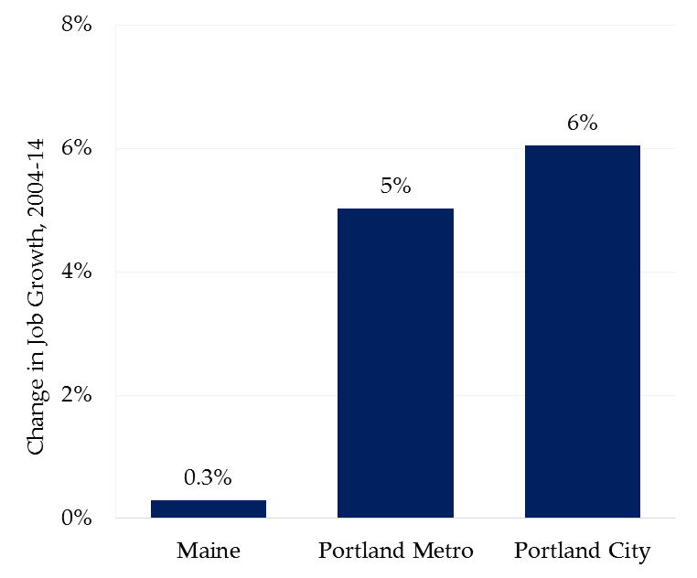

Table 1: Job Growth and Distribution, 2004-14: Portland, Portland Metro, and Maine

Location | 2004 |  | 2014 |  | Change
 | Number | Share | Number | Share | Number
Portland City | 63,791 | 11.2% | 67,648 | 11.9% | 3857
Portland Metro | 182,244 | 32% | 191,405 | 33.6% | 9161
Maine | 568,746 | 100% | 570,417 | 100% | 1671
2. Portland’s Workforce: Commuters and Residents. With the number of jobs within Portland increasing, we look to where workers come from. The number of workers reporting both working and living in Portland declined by 1232 between 2004 and 2014. Workers living in
Portland but commuting to jobs outside the city also decreased by nearly 1,000 during this period. Commuters who come from outside the city limits and are employed in Portland increased by over 5,000 between 2004 and 2014.

Table 2: Changes in Commuters and the Resident Workforce, 2004-14

 | 2004 |  | 2014 |  | Change
 | Number | Share | Number | Share | Number
Employed and Residing in Portland | 18,354 | 28.8% | 17,122 | 25.3% | -1232
Residing in Portland and Employed Outside the City | 17,303 | 27.1% | 16,327 | 24.1% | -976
Employed in Portland, Commuting from Outside of the City | 45,437 | 71.2% | 50,526 | 74.7% | 5089

Figure 2A: Changes in Commuters and the Resident Workforce, 2004-14
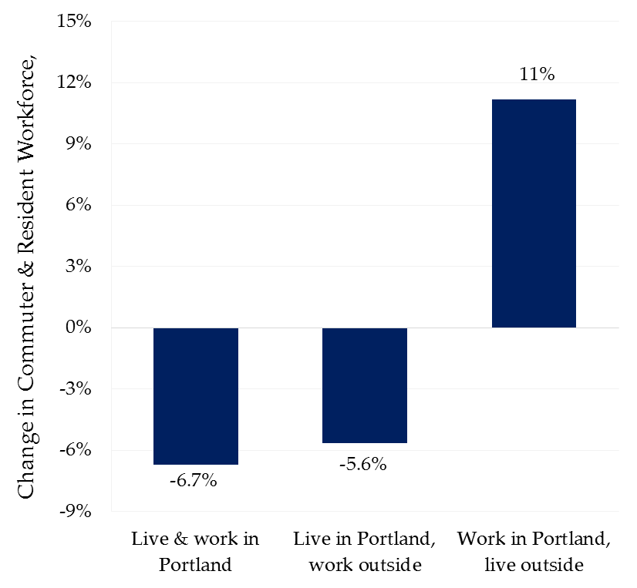

Figure 2B: Share of Commuters and Resident Workforce, 2014
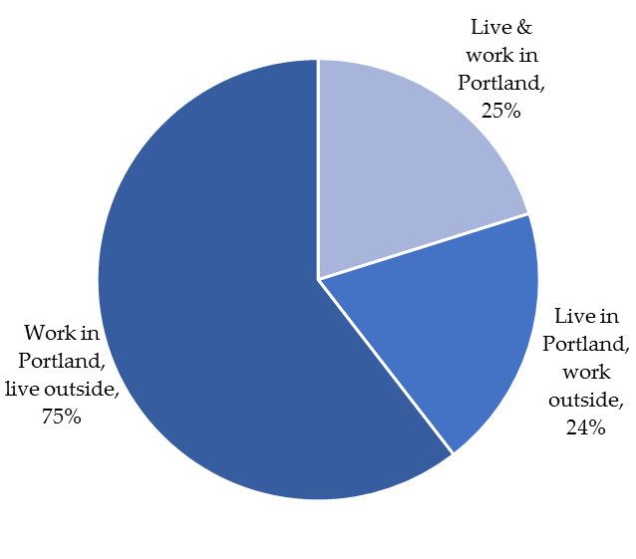

3. Age Distribution of Portland’s Workforce. Like Maine’s as a whole, Portland’s workforce is aging. Over the ten- year period 2004-14, workers age 55+ increased by 6317, and those 29 and under decreased by 862. Worker in the middle age group, 30-54, also declined by over 1400. In 2014, nearly one quarter of Portland’s workforce was age 55 or over, and with each passing year this number will continue to increase with the aging of the baby boomers.
While there remains some uncertainty about the ages when workers will actually retire, data from the Social Security Administration indicate that about 40% of Social Security eligible workers apply for benefits at age 62. On the other hand, the percentage of U.S. men age 65 and over who are working has grown from 15 to 22 percent over last 20 years. The data suggests that Portland’s employers will face significant retirements over the next 10 years, along with formidable challenges to either replace or adapt to older workers.

Table 3: Change in Age Distribution of Portland’s Workforce, 2004 -14

Age Cohort | 2004 |  | 2014 |  | Change
 | Number | Share | Number | Share | Number
Workers Aged 29 or Younger | 14,441 | 22.6% | 13,579 | 20.1% | -862
Workers Aged 30-54 | 39,354 | 62% | 37,945 | 56.1% | -1409
Workers Aged 55 or Older | 9,807 | 15.4% | 16,124 | 23.8% | 6317

Figure 3A: Change in Age Distribution of Portland’s Workforce, 2004-14
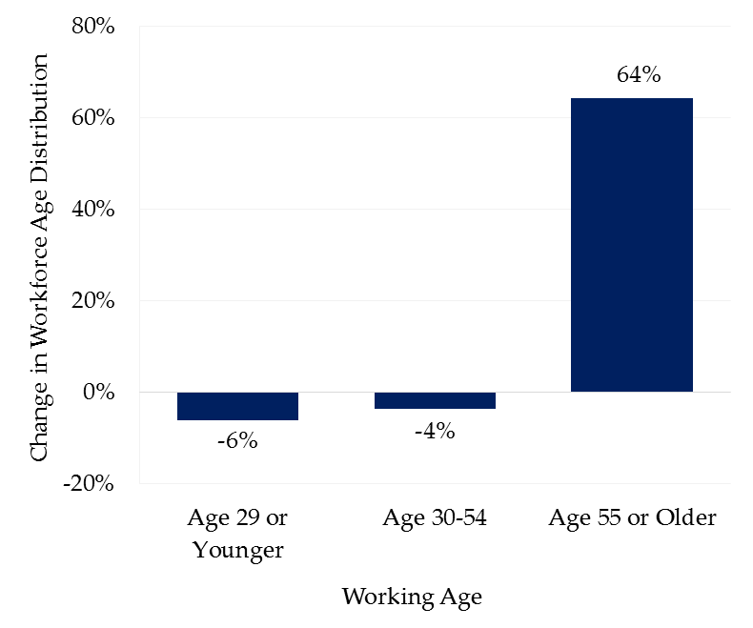

Figure 3B: Age Distribution of Portland’s Workforce, 2014
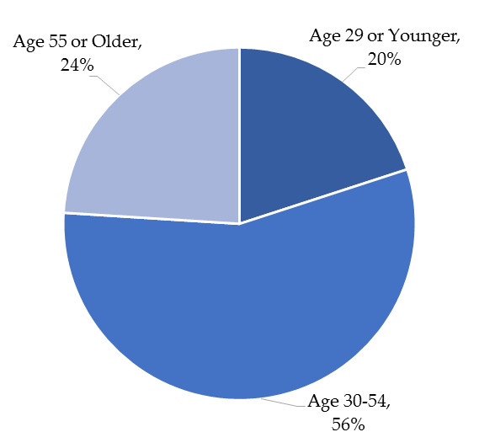

4. Earnings Distribution of Portland’s Workforce. Long- term wage stagnation has eroded the buying power and the living standards of American workers, and Maine’s are no exception. Movements to increase the minimum wage are underway across the country. A Maine referendum scheduled for this November proposes to increase Maine’s minimum wage from the current level of $7.50 per hour to $12.00 per hour by 2020. One of the most positive signs for Portland’s economy is the growth in the number of workers earning in the upper tier of the earnings distribution. The share of these earners moved from 30 % in 2004 to 45% in 2014, a gain of nearly 12,000 workers. Yet, there remain significant numbers of workers earning at the low end of the wage distribution, with nearly a 20 % share in 2014. It is low-wage workers who are most vulnerable, particularly as housing costs continue to go up at much faster rates than wages.

Table 4: Change in Monthly Earnings Distribution, Portland’s Workforce, 2004-14

Earnings | 2004 |  | 2014 |  | Change
 | Number | Share | Number | Share | Number
$1,250 Per Month or Less | 16,458 | 25.7% | 13,371 | 19.8% | -3087
$1251 to $3,333 Per Month | 28,214 | 44.2% | 23,396 | 34.6% | -4818
More Than $3,333 per Month | 19,119 | 30.1% | 30,881 | 45.6% | 11,762

Figure 4A: Change in Monthly Earnings Distribution, Portland’s Workforce, 2004-14

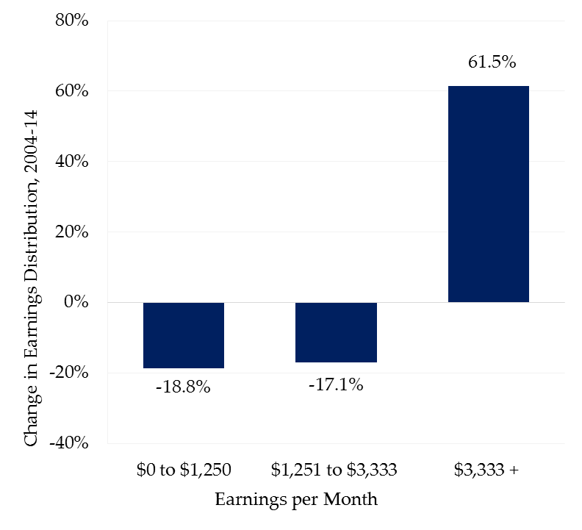

Figure 4B: Distribution of Monthly Earnings of Portland’s Workforce, 2014

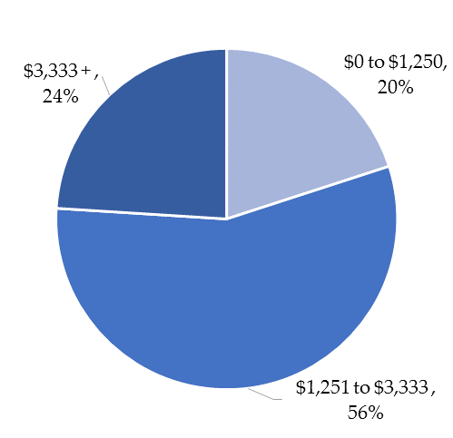

5. Leading Industry Sectors Employing Portland’s Workforce. Health care and social assistance is by far Portland’s leading economic sector, with nearly 16,000 jobs in 2014 representing a quarter of all employment. Hospitals, medical offices, mental health centers, and counseling and treatments centers are all classified under this sector. Not only does this sector dominate, it also added over 2,000 jobs between 2004 and 2014. With an aging population, Maine employment projections call for even more growth in the sector over the next ten years, covering a wide range from specialty physicians and top managers to entry-level housekeeping and basic patient care. Salaries range from among the highest in the state to entry-level. There are many technical and nursing jobs that pay good salaries and offer advancement. It is noteworthy that fully 30 % of the workers in health care and social assistance in the Portland metro region were 55+ years of age in 2015.

Finance and insurance, with over 6,000 jobs in 2014, also showed significant growth between 2004 and 2014. Nearly 2500 jobs were added during the period, making this sector the largest job creator in Portland. Executive, managerial, technical, sales, and support positions make up the sector, and workers 55 years of age and older make up 23% of this workforce.
Professional, scientific and technical services have long been a mainstay of the Portland economy. Lawyers, accountants, consultants, researchers, and many others with specialized skills make up the sector. Nearly 1,000 professional, scientific and technical jobs were added in Portland between 2004 and 2014, typically paying high wages. A quarter of the workforce in this sector was 55+ years of age in 2015.

The accommodation and food services sector has also shown growth, with 1023 jobs added between 2004 and 2014. The addition of new hotels and restaurants in Portland has helped to add jobs and increase employment share of this sector from 7.2 to 8.3 percent between 2004 and 2014. Most jobs in this sector tend to be in middle management and service occupations with pay in the middle to low end of the earnings distribution. Finally, Portland’s retail sector has remained mostly flat in terms of jobs, with an 8.5 percent share in 2004 dropping slightly to 7.9 in 2014. There are many seasonal jobs in this sector and pay tends to be on the low end.

Table 5: Employment Change in Portland’s Top Five Industry Sectors, 2004-14

Industry Sector | 2004 |  | 2014 |  | Gain
 | Number | Share | Number | Share | Number
Health Care and Social Assistance | 13,944 | 21.9% | 15,980 | 23.6% | 2036
Finance and Insurance | 3,789 | 5.9% | 6,225 | 9.2% | 2436
Professional, Scientific and Technical Services | 4,895 | 7.7% | 5,865 | 8.7% | 970
Accommodation and Food Services | 4,572 | 7.2% | 5,595 | 8.3% | 1023
Retail Trade | 5,403 | 8.5% | 5,345 | 7.9% | -58
Balance of Sectors | 31,118 | 48.8% | 28,638 | 42.3% | -2,480

Figure 5A: Employment Change in Portland’s Top Five Industry Sectors, 2004-14
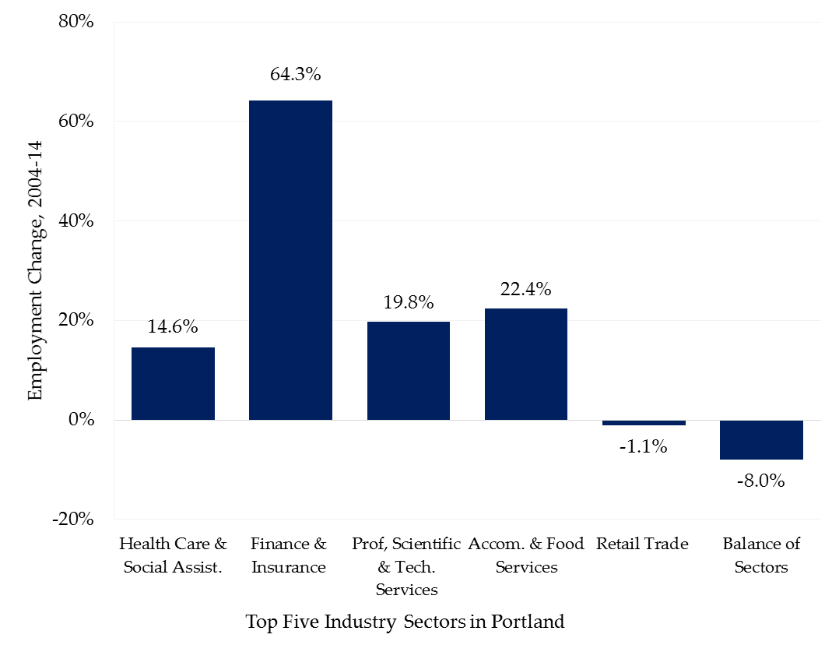

Figure 5B: Employment Distribution in Portland’s Top Five Industry Sectors, 2014
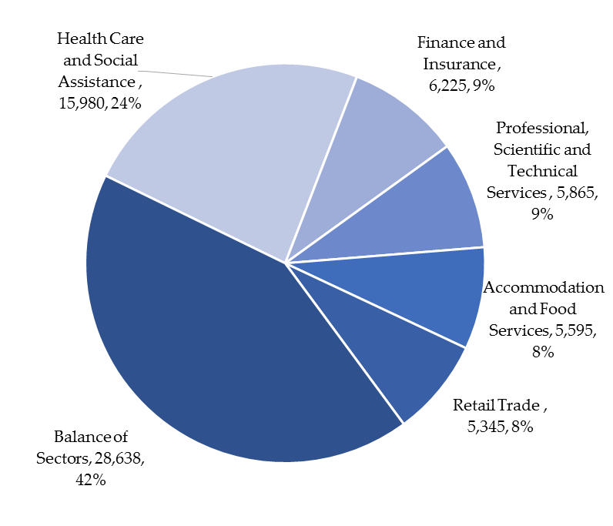

IV. “The New Allure of the City (and Some Unanticipated Consequences)”
A Public Lecture by Alex Krieger, FAIA
On October 25, 2016, Alex Krieger, Professor in Practice of Urban Design at the Harvard University Graduate School of Design, delivered an illustrated lecture to an audience of some 300 in the Portland High School Auditorium. A reception followed.
The event was presented by the Center for Global Humanities at the University of New England, in partnership with Creative Portland and the Portland Society for Architecture, and in collaboration with the Portland Regional Chamber of Commerce and Muskie School of Public Service, additional funding provided by the Press Hotel and Random Orbit.
Welcoming remarks were delivered by Patrick Costin, President of the Portland Society for Architecture. Professor Anouad Majid, Director of the UNE Center for Global Humanities then introduced Professor Krieger. Following is a summary of Professor Krieger’s remarks by Richard Barringer, Emeritus Professor in the Muskie School of Public Service.

Beginning in 2008, humanity became an urban species for the first time in its long history, as more people world-wide resided in cities than in rural or suburban places. Something similar happened in the United States a little over a hundred years ago, the eventual response to which was for the nation to suburbanize under the influence of urban blight and a variety of federal policies, including interest rate subsidies, the GI Bill, and the interstate highway system. Today the suburbs are not dead, although the rate of their growth is on the decline. The question before us is, should we or will we continue to become largely an urban species? Should do a turn-about?
We must ask, what are cities for, anyway? Two thousand years ago Aristotle gave an answer: people first came to the city for security, to escape the barbarians; what they found was economic opportunity; and they stayed for “The Good Life.” Change is now happening and “propinquity,” the desire to live near other people, is now popular as the result of both lifespan and fashion trends.
The basic purpose of life in the suburbs, or what might be called “Life by the Acre,” is family-building. But this served its purpose when the percentage of the adult population raising children was almost 60 percent; today, it is just 24 percent; and both the young and the old today prefer what may be called “Life by the Square Foot,” with all its opportunities and amenities. Youth stay young longer even as the old stay alive longer. So, for some 75-80 percent of today’s population, life outside the city is no longer of interest.
In this setting, we must encourage our city to think about its own transformation, to get past fear of change and encourage growth, making sure that we realize all of its benefits!
In this Second Urban Age, there are a number of useful indicators of city health:
- Living First, as Vancouver likes to say of itself. The key to this is a great range of housing types (including three deck’ers, a great invention) that the neighborhoods must support.
- Ed’s and Med’s, or education and hospitals as leaders of urban economies and lifestyles. Cite Qatar and Dubai as examples.
- Mixed-use neighborhoods, with strong emphasis on creative re-use of historic structures;
- Compact development, consolidated and concentrated.
- Overcome the gaps in development, fill them in!
- Invest in Culture, a diversity and lots of it, to create fun places to go and be!
- Alternative Forms of Mobility, like Pittsburgh’s ferries and cable car, and understand transit as a form of social learning and sociability;
- Greening, like Boston’s Emerald Necklace: pursue conservation, access to greenways, tree plantings, etc.; and
- Work at it! Authenticity and distinctiveness matter! “Keep Portland Weird!”
Finally, a special word about the proposed removal and redevelopment of 1-295 from Congress St. to Tukey’s Bridge: Proceed, go for it! It may take 20 years, but its removal will create a Better City, a Better Life for All. See Shanghai, China, Seoul, Korea, and Washington D.C for comparable redevelopments of urban highways. In each case, “Wonderful environments bring great investment!” We must re-embrace our city and make of it a great environment for people to live, work, visit, and play.
In response to audience questions, Prof. Krieger remarked:
Housing affordable to all. There is a great challenge and downside to the urban renaissance, in that people need to afford to take advantage of the city. A variety of policies are needed, and we must be more flexible in what we will allow. Fully half the new housing in Boston now has to be priced for working families. There is resistance to change in our cities that makes it harder to accommodate more people. We must be more generous!
Be incremental. Building big things in small cities is very hard; instead, try a little more height, infill, etc.
Innovation and diversity matter. Support individual innovators, invite them in, make them welcome.
Jobs Follow People. Job opportunities go where the talent is, where the people are. Just look at all of America, as jobs went to the suburbs in the 1960s and 70s, following the population shift. Rtes. 128 and 495 in Massachusetts are examples.
Thank you! (Prolonged applause!)

This collaboration is a follow-on to the very successful conference, Challenge and Change: Are We Loving Portland to Death?” organized in Fall 2015 by Creative Portland and the Portland Society for Architecture. The several organizations involved in the collaboration intend to advocate for and participate in implementing the workforce and urban design concepts and recommendations developed here. Collaborators wish to express appreciation and gratitude to the city’s offices of finance and planning for their advice and assistance in the preparation of this paper. Any errors or omissions it may contain, as well as the opinions expressed are the sole responsibility of the authors.
See Portland Planning and Urban Development Office memorandum of September 7, 2016.
The authors are grateful to colleague Patrick Costin for his suggestion of the flow diagram to illustrate the forces here at play.
September 4, 2015
A recent article in City Observatory, “States on the Front Line of Housing Affordability,” argues that “For advocates of less restrictive building regulations, especially in high cost cities where more homes might help bring down housing prices and create more equitable and diverse neighborhoods, State governments often seem like the best bet. At the local level the politics are incredibly difficult…. State-level policies that both encourage and require the construction of below-market housing while potentially increasing production of market housing as well, helping slow the growth of market prices, potentially carry a much greater impact for affordability than local policies like inclusionary zoning. See http://cityobservatory.org/states-on-the-front-lines-of-housing-affordability/
See Portland Press Herald, June 24, 2016.
See brief talk by Prof. Krieger at https://www.youtube.com/watch?v=hSr3BxmVIdI. Appendix IV. offers a summary of his October 25, 2016, public lecture at Portland High School, “The New Allure of the City.”
See Edward Glaeser, Triumph of the City: How Our Greatest Invention Makes Us Richer, Smarter, Greener, Healthier, and Happier. Penguin Books, 2011.
Jane Jacobs, The Death and Life of Great American Cities, Vintage Books, 1961.
See https://www.cnu.org/publicsquare/2016/08/26/morbid-and-mortal-toll-sprawl
The number of jobs in Portland increased by 4,000 between 2004 and 2014. But while the number of workers both working and living in Portland declined by 1232 during this period, commuters from outside the city and working in Portland increased by more than 5,000. Source: U.S Census Bureau, OnTheMap Application Origin-Destination Employment Statistics
See, for example, “Why Corporate America Is Leaving the Suburbs for the City,” The New York Times, August 1, 2016. “Cities are more attractive places to live than they were 30 years ago, and are more willing to provide tax incentives; and young people want to be there.” – David J. Collis, Harvard Business School.
The City owns and operates some 17 schools: 10 elementary, 3 middle, and 4 high. It recently issued an RFP for a qualified inspector to assess the maintenance and improvement needs of all but one of the schools, as well as the central kitchen and administrative office; and to place each of these facilities on a long-term maintenance schedule. The report is expected by late Fall 2016.
See City of Portland Capital Improvement Plan, FY 2016-20-2020, April 2-015.
Total net debt service may not exceed 15% of total general fund expenditures or 1.5% of total per capita income for the city based on US Bureau of Economic Analysis figures. Total debt should also not exceed $5,000 per capita.
Arnold J. Toynbee, A Study of History, originally published in 1946, paperback edition abridged in two volumes by D.C. Somervell, Oxford U. Press, Oxford and New York, 1987.
The Maine Department of Labor recently reported that seven out of every eight Maine job openings between now and 2024 will be to replace an existing worker who vacates a position by retiring, quitting, or being fired. Maine’s continuing transition to a service economy will lead to population shifts within the state, as people relocate to more urban places where the majority of jobs will be. “The industries that are growing (health care and professional services) tend to be in the cities,” said chief economist Glenn Mills. See Portland Press Herald, Sept. 13, 20i6.
See Maine’s New Labor Shortage: New Mainers and Diversity, Maine Development Foundation and Maine State Chamber of Commerce, Augusta, September 2016.
See http://focusmaine.org/signature-industries/
The U.S. Census reports that Portland’s population peaked at some 77,000 in 1950, and after a long period of decline has stabilized today at some 66,000 persons.
This is a safety issue as well as one of good urban design. Highway engineers advise that tight spacing of interchanges along I-295 between Baxter Blvd. and Congress St. East (north to south) – seven points of departure within 2.5 miles – fails to give motorists adequate sight distance and perspective; creates excessive weaving and merging at 55mph; and is inconsistent on safety grounds with AASHTO standards for interstate design. See the “Green Book” sections 6.2.1 and 6.2.2, and https://www.fhwa.dot.gov/design/interstate/pubs/access/access.pdf.
In June 2016 the Portland City Council adopted the Franklin Street Final Design Report, dated July 2015; see this and concept drawings for the re-designed Franklin St. at www.portlandmaine.gov/documentcenter/home/view/14304.
John B. Robinson, A Concise History of Portland, Maine, Warren Machine Company, 2008, p.4.

